Exercise 1:
Effort: 25 min
In this lab, We'll create a web page with details of Yours.
Objectives
After this exercise, you will be able to do the following:
1. Create a new HTML document
2. Specify DOCTYPE
3. Add the head and body elements
4. Add a title
5. Add a heading
6. Add a paragraph
7. Add an image
8. Create a list of items
9. Add a table of data
10. Add Links to other pages

Exercise 2:

Objective:
Create a personal portfolio webpage using HTML to showcase your professional background, education, interests, and provide a functional contact form for visitors to reach out.

Requirements:
- Use all the required tags in html.
- Use semantic tags like: <section>, <nav>, <aside>, <header>, <footer>.
- Use the <form>, <input>, and <textarea> tags for the form elements.

Components:

1. Navigation
Create a navigation for different sections like short bio, education, interest, contact. If clicked, the user must be redirected to the respective section.

2. Short Bio
Create an HTML section for your short bio. Use appropriate tags extensively to structure the content. Include Name and Interested field using semantic tags. Embed an image of yourself within the bio section.

3. Education History
Construct a section for your education history.Make a table stating all your education history,

4. Interests and Hobbies
Implement an HTML section for your interests and hobbies. Use lists or paragraphs(at least three interests and three hobbies.) to present this information.

5. Contact Form
Create an HTML form for visitors to leave messages. Include fields for Name, Email, and Message along with a submit button.

6. Footer:
Footer section must include copyright information for your website. (eg: ​​Copyright © 2023 Your Full Name. All rights reserved.) Also include your social media links.

You can include additional links like resume, projects.

Submission Guidelines:
- Save your HTML code in a single file (e.g., firstname_lastname_studentid.html).
- Ensure all file paths for images are correct.
- Submit the file to my second teacher’s portal.

Note: After applying CSS, the webpage will look like this. We'll work on creating it next week.

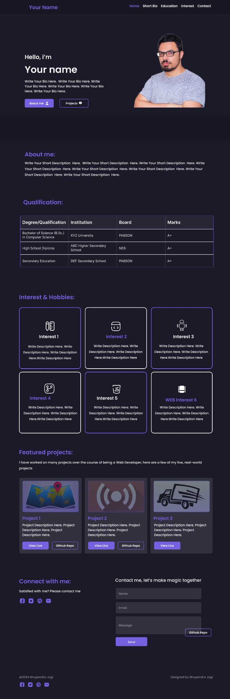




Figma file: https://www.figma.com/design/XcdU9EwRI9ArIXUs4sETVk/Portfolio-Site?node-id=0-1&t=f3ssDEXKQZbz5gu9-1

